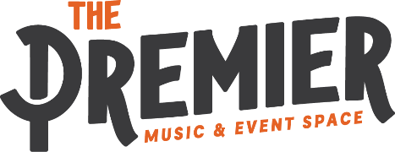

RENTAL SPECS & AMENITIES

- 5000+ SF Venue + Bar
- Max Occupancy Standing – 643
- Max Occupancy Seated – 265
- Ticket Window/Coat Check/Office
- Multi-Stall + Individual Restrooms
- 150SF Private Room with Sofas and Restroom
- State of the Art, Whole-Venue Sound and Lighting System
- Full-Size Stage with Mics
- Sound and Lighting Techs Available (as add-on)
- Bar Stocked with Beer, Wine, Liquor & Non-Alcoholic Bevs (for sale)
- Bar, Venue & Security Staff Provided (as needed)
- Bar Tables and Stools
- Parking with +/- 50 Capacity
- Exclusive Parking Area for Food Truck
- Dock for Equipment Load-in/Load-out
- Separate Smoking Patio
- 6 - 5’ Round Tables (seats 6)
- 6 - 6’ Rectangle Tables (buffet or seats 6)
- 10 - 24” High Top Tables
- 100 - Chairs
- 6 - Cornhole Game Sets

